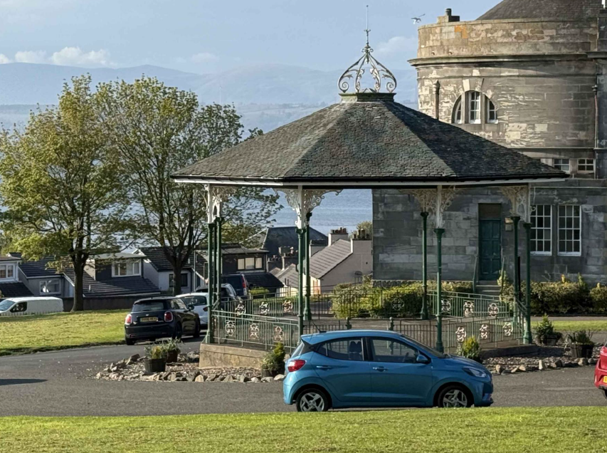
Questionnaire on The Glebe Bandstand Restoration Project
Important : The timeframe for implementation of this project is currently unknown, as it depends on securing funding from a number of organisations
1.0 Name and contact details of your group :

2.0 Does your group use The Glebe Bandstand and if so please describe briefly how you use it :

3.0 Do you agree that a proposed project by Falkirk Council, to restore The Glebe Bandstand to its original design, using traditional materials and traditional building skills would bring benefits to your group and the wider community ? Please only answer yes or no

4.0 What difference would The Glebe Bandstand being fully restored make to your group :

5.0 What difference would The Glebe Bandstand being fully restored make to the whole community :

6.0 Is your group interested in attending or assisting Falkirk Council with future events and activities, that offer the local community the chance to learn about traditional building skills and to increase knowledge about the history of The Glebe Bandstand and its role in the community? If yes, please describe briefly how your group could assist

Please return this questionnaire with your answers by Friday, 26th September 2025 to ruth.simpson@falkirk.gov.uk and thank you for your support !

